Additional file 1. HPLC elution profiles of metabolites from ROL leaves. The MS chromatograms were monitored at 280 nm.
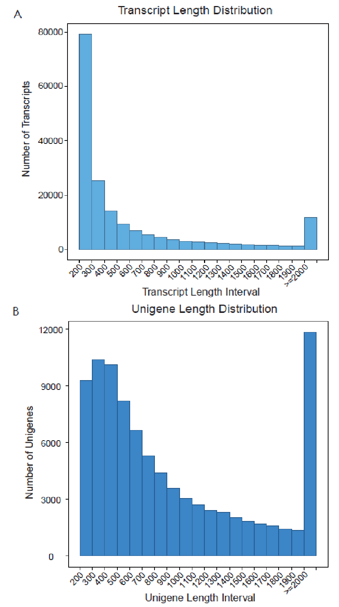
Additional file 2. Overview of the denovo transcriptome assembly. (A): Length of transcripts assembled from high-quality clean reads by Trinity. (B): Length of unigenes generated from further transcripts assembly.

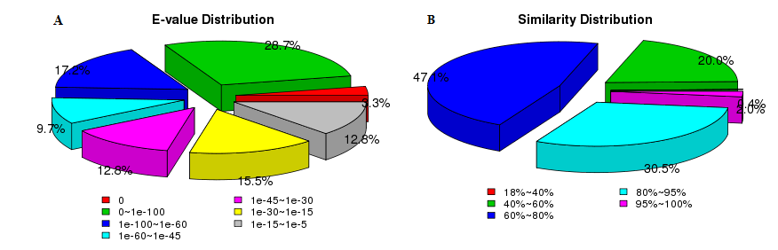
Additional file 3. Characterization of the assembled unigenes based on NR protein database search. (A): E-value distribution of BLAST hits for the assembled unigenes with a cutoff of E-value <10⁻⁵. (B): Similarity score distribution of the top BLAST hits for the assembled unigenes with a cutoff of E-value <10⁻⁵.

Additional file 4. Primers list of Rt-qPCR
No | Gene ID | Primer (5’-3’)
1 | Cluster-14354.34366 | qF-GATGGAGTGAGCCACACAGTT
2 | Cluster-14354.34366 | qR-TCAGCAGATGTTGTCAGCGAG
3 | Cluster-14354.36512 | qF-TGCCGACAAGGACAACTATCT
4 | Cluster-14354.36512 | qR-CGTTCCATAGGGTGTTGTCGT
5 | Cluster-14354.38156 | qF-TCACCGCAAACCACCCAT
6 | Cluster-14354.38156 | qR- GGTGGCAAGGAGGGAGTA

Additional file 5. Reaction system of Rt-qPCR
Components | Volume (Total Volume 20 μl)
2×TransStart Green qPCR SuperMix UDG | 10 μl
Templet | 1 μl
Forward primer (10 μM) | 0.4 μl
Reverse primer (10 μM) | 0.4 μl

